Community Member Discovery for Member
Users  - Primary  - Community members  - Secondary | Phase 1
Intended Outcome
- Members can explore the other members based on community member identification
Links
- …
- …
- …
- …
- …

Introduction
Members can browse a directory of fellow accepted members, seeing only public membership information such as nickname and core identity answers required at registration. Sensitive details like WhatsApp numbers or membership IDs are kept private. With this approach, Kolavo helps everyone feel safe while reinforcing the shared identity that holds each community together.

Product Requirement
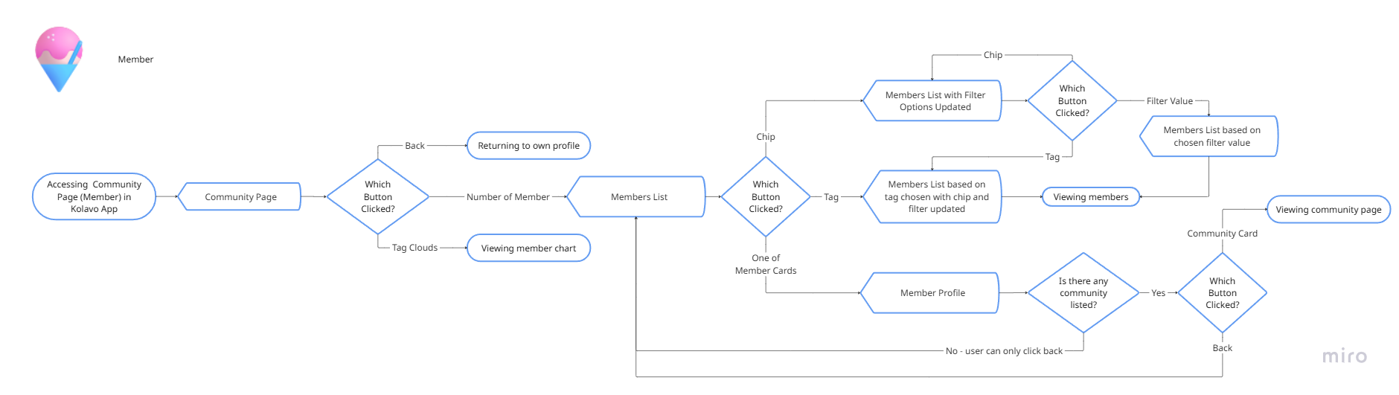
Flow of Community Member Discovery for Member

No | User story | Scope | Acceptance Criteria
1 | As a newly accepted community member, I want to receive a notification that my membership application has been approved, so that I feel acknowledged and included in the community. | Welcome Notification for Accepted Member | - Upon approval, the member receives an email stating they have been accepted into the community.  - Notification includes a direct call-to-action to explore their community and discover other members.  - The CTA directs them to open related community in a new tab  - Notification is sent immediately upon approval, not batched or delayed.
2 | As a newly accepted member, I want to be encouraged to explore and get to know other community members, so that I am motivated to become more active in the community. | Onboarding Prompt to Discover Members | - After receiving acceptance notification, the member is shown a clear prompt encouraging them to check out other members.  - Prompt includes a direct link or button to the community member directory.  - The onboarding prompt is displayed only once after first acceptance or until dismissed.
3 | As an accepted member, I want to view a list of other accepted members with only public identification information, so that I can safely learn about other members without seeing or sharing sensitive details. | Public Member Directory (for Members) | - The member directory shows only accepted members of the same community.  - Directory entries display:  - Profile picture or initials  - Nickname (Nama Panggilan)  - Core identity answers that were required/public at registration  - No confidential fields are shown (no WhatsApp number, no member ID, no contact info, no verification note).  - Directory is readable, scannable, and accessible on both desktop and mobile.  - Members cannot see pending, rejected, or removed users.  - Members cannot view full “profiles” beyond what is defined as public identity info.
4 | As an accepted member, I want to filter members based on category and value, so I know whether my batches are joined. | Group Chips & Quick Filter | - A row of group chips which are [question title] appears at the top.  - Clicking a chip filters the member list by that identity field.  - A secondary dropdown allows filtering by value within the chip which are the answers of the questions in registration form.  - Only identity fields and categories with joined members appear as chips.  - Filtered results update member cards below, no page reload.
5 | As a community member, I want to see member identifications in an attractive way as well as functional, so I can easily know who the members are and filter based on who they are. | (Member Identification as) Tags | - Show member identification as tags  - Each tag has color that represent each chip  - Clicking each tag auto choosing chip and filter value.
6 | As a community member, I want to see what other communities that my fellow members join, so I can know what other communities exist that I can also join. | Fellow Member Community Profile | - Fellow member community profile is a page containing a public personal profile and list of communities joined.  - Rejected and pending communities not shown.  - This page can only be accessed by fellow members through communities they are in.  - Personal profile include:  - Profile picture  - Nickname related to communities  - Domicile (if filled)  - Communities include:  - Logo  - Community abbreviation  - Membership status

Design Requirement
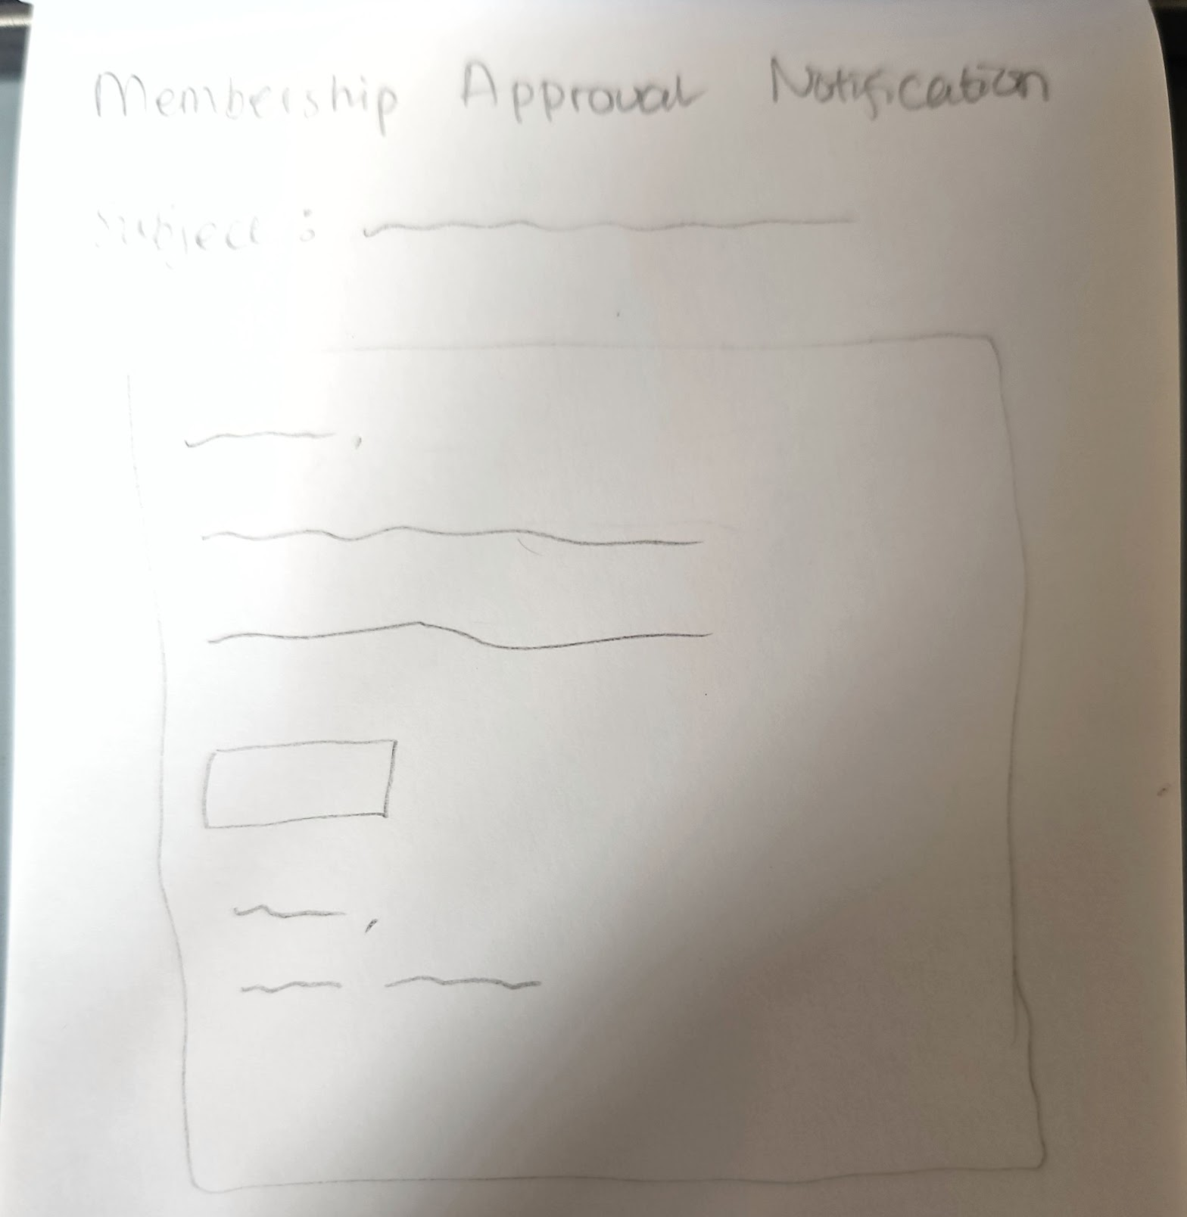

Email Notification
Design Intent | To notify users about their membership approval
Content / Copy | - Subject: Selamat! Kamu Resmi Menjadi Anggota [Community Short Name]  - Email Body:  Hai [Nick Name],  Pendaftaranmu sudah diterima. Kini kamu resmi menjadi anggota [Community Long Name]!  Yuk, buka komunitasmu untuk mulai mengenal anggota lainnya.  - CTA: Lihat Komunitas  - Sign:  Salam Kolaborasi,  Kolavo X [Community Short Name]
Visual Requirement
Interaction Behavior | - New tab is open as CTA is clicked
Acceptance Criteria
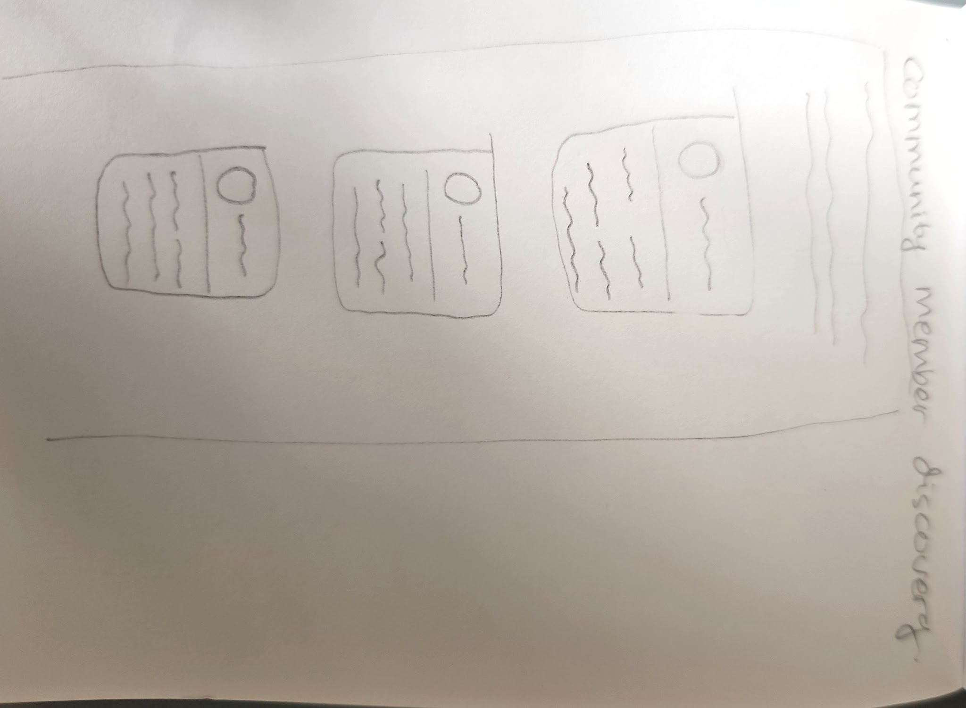

Member Onboarding Modal
Design Intent | To welcome new members and encourage them to take a look at their group
Content / Copy | - Title: 👋 Kenalan dengan Anggota Komunitasmu  - Body: Sekarang kamu resmi jadi anggota! Lihat siapa saja yang ada di komunitas ini.  - CTA (Button): Lihat Daftar Anggota
Visual Requirement
Interaction Behavior | - CTA directs to community member directory
Acceptance Criteria

Breadcrumbs
Design Intent | To ease members knowing where they are and how to return to previous page
Content / Copy | - Mobile: < Daftar Anggota  - PC: Komunitas > [community abbreviation] > daftar anggota > [member nickname]
Visual Requirement
Interaction Behavior | - Clicking < returns to previous page
Acceptance Criteria

Community Member Directory
Design Intent | To make members feel united as they see who they are with in communities
Content / Copy | - Heading: Anggota [community abbreviation]  - Subhead: Cari tahu siapa saja di komunitas ini, dan rasakan kebersamaan lewat identitas yang kalian bagi bersama.
Visual Requirement
Interaction Behavior
Acceptance Criteria

Group Chips and Filter
Design Intent | To ease admins finding certain group of members
Content / Copy | - Chips name: [question title]  - Filter:  - Filter label: Filter:  - Placeholder: Pilih [question title]  - List of filter: [answers from selected question title]
Visual Requirement
Interaction Behavior | - Content filter changes as users click each chip  - Member cards shown changes as users click each chip and filter
Acceptance Criteria

(Member Identification as) Tags
Design Intent | To ease admins scanning and filtering their members
Content / Copy | - Tags: maximum 5 of [member identifications]
Visual Requirement | - The order of tag is same with the order of chips  - Each tag shows different color representing chip/category
Interaction Behavior | - Clicking one of tags auto selecting chips and filter value which results showing member cards based on chips and filter value
Acceptance Criteria

List of Member Cards
Design Intent | To trigger members’ memories with the community by looking at each card where member community identities shows up
Content / Copy | - Member Profile  - Member profile picture  - Member nickname  - Member community identities
Visual Requirement
Interaction Behavior | - Clicking one of member cards activates border card following community color theme
Acceptance Criteria

Fellow Member Profile
Design Intent | To allow members knowing fellow members by looking and exploring at fellow members profile and communities
Content / Copy | - Member Profile  - Member profile picture  - Member nickname  - Domicile  - Communities:  - Logo  - Community abbreviation  - Membership status  - Admin: Pengurus  - Member: Anggota
Visual Requirement | - Membership status using Kolavo brand colour  - Admin colour using blue  - Member colour using orange
Interaction Behavior | - Clicking one of community cards directs to selected community page
Acceptance Criteria

Engineering Requirement

Questions

